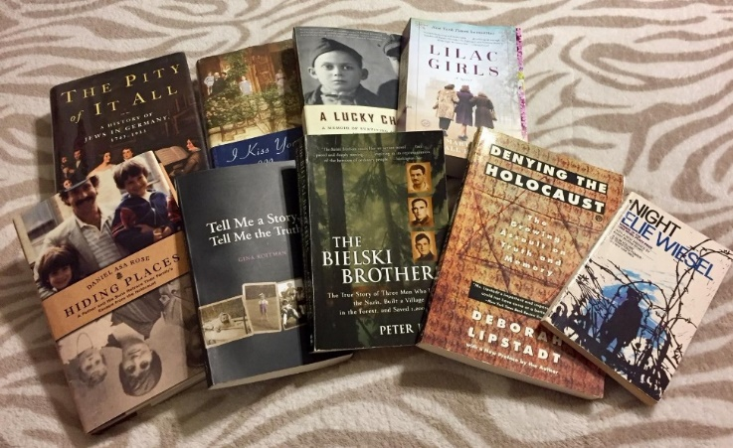
Books discussed by the 2nd Generation Book Group

Aciman, Andre Out of Egypt: A Memoir
Ackerman, Diane The Zookeeper’s Wife
Applefeld, Arahon A Story of a Life
Blum, Jenna Those Who Save Us
Dershowitz, Alan Just Revenge
Doerr, Anthony All The Light We Cannot See

Duffy, Peter The Bielski Brothers: The True Story of Three Men Who Defied the Nazis,

Built a Village in the Forest, and Saved 1,200 Jews
Edsel, Robert and Bret Witter The Monuments Men:
Allied Heroes, Nazi Thieves and the Greatest Treasure Hunt in History
Ehrlich, Elizabeth Miriam’s Kitchen
Elon, Amos The Pity of it All: A Portrait of Jews in Germany 1743–1933
Foer, Jonathan Safran Everything is Illuminated (a short film)
Epstein, Helen Children of the Holocaust
Frankl, Viktor E Man’s Search for Meaning
Franklin, Ruth A Thousand Darknesses: Lies and Truth in Holocaust Fiction
Fremont, Helen After Long Silence
Fromberg-Schaeffer, Susan Anya

Hahn-Beer, Edith with Susan Dworkin
The Nazi Officer’s Wife: How One Jewish Woman Survived the Holocaust
Hoffman, Eva Lost in Translation: A Life in a New Language
Hunter, Georgia We Were the Lucky Ones
Kelly, Martha Hall Lilac Girls: A Novel
Kent, Roman Courage was my Only Option: The Will to Survive—the Strength to Remember

Larson, Erik In the Garden of Beasts
Levi, Primo This Is a Man
Lipstadt, Deborah Denying the Holocaust
Lower, Wendy Hitler’s Furies: German Women in the Nazi Killing Fields
Lowry, Lois Number the Stars (reviewed with other Children’s books)
Mendelsohn, Daniel Lost: A Search for Six of Six Million
Moorehead, Caroline Village of Secrets: Defying the Nazis in Vichy France
Morris, Heather The Tattooist of Auschwitz—an historical novel
Nemirovsky, Irene Suite Francaise
Neumann, Ariana When Time Stopped: A Memoir of My Father's War and What Remains
Offenberger, Ilana Fritz The Jews of Nazi Vienna: 1938–1945 Rescue and Destruction
Roitman, Gina, Tell Me a Story, Tell me the Truth (author is the mentor of Generations After Writing Grp)

Rojstaczer, Stuart The Mathematician’s Shiva
Rose, Daniel Asa Hiding Places
Sands, Philippe The Ratline: The exalted Life and Mysterious Death of a Nazi Fugitive
Pentlin, Susan Lee The Diary of Mary Berg: Growing Up In The Warsaw Ghetto (edited by SL Schneiderman)

Roy, Jennifer Yellow Star (about a member’s mother. Author joined meeting)
Schuster, Ben Zion; A Rejected Stone (by father of member Paula Schuster,
Translator: Dr. Shapiro joined meeting)

Stone, Judy (member) Resilience: One Family’s Story of Hope and Triumph Over Evil
Suchman, Bonnie Broken Promises
Szpilman, Wladyslaw The Pianist (included Pianist playing the music from the film of his book)

Szegedy-Maszak, Marianne I Kiss Your Hands Many Times
Wiesel, Elie Night
Wildman, Sarah Paper Love: Searching for the Girl My Grandfather Left Behind
Wyman, David The Abandonment of the Jews: America and the Holocaust 194–1945
Wyszogrod, Morris A Brush with Death: An Artist in the Death Camps
Yolen, Jane The Devil’s Arithmetic

Additional programs with the authors
sponsored by The Generations After
Member Authors of the 2nd Generation Book Group
Alpern, Ingrid My Separate Worlds and The Doll
Gaspar, Gail Carrying My Father’s Torch—From Holocaust Trauma to Transformation
Stone, Judy Resilience: One Family’s Story of Hope and Triumph Over Evil
5/24/20 program, “Children of Holocaust Survivors: Where Are We Now?”
Epstein, Helen Long Half Life of Love and Trauma
Franci’s War

2/10/20 at Busboys and Poets in Takoma Park, MD
Fremont, Helen Escape Artist

Generations After Fall Tea Presenters:
Goldsmith, Martin The Inextinguishable Symphony:
A True Story of Music and Love in Nazi Germany

Alex’s Wake: The Tragic Voyage of the St. Louis to Flee Nazi Germany-and a Grandson’s Journey of Love and Remembrance

Buergenthal, Thomas A Lucky Child

